TUTORIAL – 9
Black-Box & White-Box Testing
Software Testing – Test Report
Application Under Test: | nopCommerce Demo Store
Website URL: | https://demo.nopcommerce.com/
Tester Name: | Software Testing Student
Test Environment: | Windows 11, Google Chrome, Visual Studio Code (for the Python White-Box demonstration)
Test Date: | 26/08/2026
SDLC Model: | Waterfall Model

Testing Overview
This report documents Black-Box, White-Box, Integration and System Testing performed on the nopCommerce Demo Store, an e-commerce web application. Black-Box Testing covers the login, product search and shopping cart features from a user's point of view without examining internal code. White-Box Testing is demonstrated using an accompanying Python program that models the login and cart decision logic, so that internal branches and conditions can be examined. Integration Testing verifies that the login, product browsing and cart modules pass data correctly between each other, and System Testing verifies the complete end-to-end shopping workflow on the live demo site.
Actual functional testing (Black-Box, Integration and System) was performed directly on the nopCommerce Demo Store at https://demo.nopcommerce.com/. The Python program used for White-Box Testing is an academic decision-logic demonstration only and is not the actual source code of nopCommerce.

Black-Box Testing Results
Black-Box Testing verified the visible functional behaviour of the login form and product search on the actual nopCommerce Demo Store, without reference to internal code.
Test Case ID | Scenario | Result Summary | Status
TC09-01 | Open home page | Home page loaded successfully | Pass
TC09-02 | Blank login fields | Validation message displayed | Pass
TC09-03 | Invalid login credentials | Invalid login error displayed | Pass
TC09-04 | Valid login credentials | Logged in successfully | Pass
TC09-08 | Product search | Relevant product list displayed | Pass

White-Box Testing Results
This Python program is an academic White-Box testing demonstration and is not the actual source code of nopCommerce. It models the login and cart decision logic so that internal branches (blank fields, invalid credentials, valid login, and the add-to-cart choice) can be examined.
Test Case ID | Scenario | Result Summary | Status
TC09-05 | Blank-field branch | "Username required" branch executed | Pass
TC09-06 | Invalid-credentials branch | "Invalid login credentials" branch executed | Pass
TC09-07 | Valid-login / add-to-cart branch | Both branch messages executed correctly | Pass

Integration Testing Results
Integration Testing confirmed that data flows correctly between the login, product search and shopping cart modules of the actual nopCommerce Demo Store.
Test Case ID | Scenario | Result Summary | Status
TC09-08 | Search module | Search results displayed correctly | Pass
TC09-09 | Search-to-cart data flow | Product added and cart updated | Pass
TC09-10 | Cart module verification | Cart contents correct | Pass

System Testing Results
System Testing validated the complete end-to-end shopping workflow – from login, through product search and selection, to shopping cart verification – on the actual nopCommerce Demo Store.
Test Case ID | Scenario | Result Summary | Status
TC09-11 | End-to-end login-to-cart workflow | Full workflow completed successfully | Pass

Detailed Scenario-wise Results
The table below lists every scenario executed, matching the Scenario IDs used in Practical_9_Test_Cases.xlsx.
Scenario ID | Scenario | Test Steps | Test Input | Expected Results | Actual Results | Status
TC09-01 | Open the nopCommerce Demo Store home page | 1. Launch Google Chrome  2. Navigate to the nopCommerce Demo Store URL | URL: https://demo.nopcommerce.com/ | Home page loads successfully | Home page loaded successfully | Pass
TC09-02 | Submit login form with blank credentials | 1. Go to the Login page  2. Leave Username/Email and Password blank  3. Click Log in | Username: blank, Password: blank | System prompts for required login fields | Validation message displayed for blank fields | Pass
TC09-03 | Submit login form with invalid credentials | 1. Go to the Login page  2. Enter invalid Username/Email and Password  3. Click Log in | Username: wronguser, Password: wrongpass | System rejects login and displays an error message | Invalid login error message displayed | Pass
TC09-04 | Submit login form with valid credentials | 1. Go to the Login page  2. Enter valid Username/Email and Password  3. Click Log in | Username: testuser, Password: test123 | User is logged in successfully | User logged in and redirected to the account page | Pass
TC09-05 | White-Box: verify blank-field decision branch | 1. Run the academic Python authentication demonstration  2. Enter blank username/password | username = "", password = "" | Program prints "Username required" branch message | "Username required" branch executed correctly | Pass
TC09-06 | White-Box: verify invalid-credentials decision branch | 1. Run the academic Python authentication demonstration  2. Enter invalid username/password | username = "wronguser", password = "wrongpass" | Program prints "Invalid login credentials" branch message | "Invalid login credentials" branch executed correctly | Pass
TC09-07 | White-Box: verify valid-login and add-to-cart decision branch | 1. Run the academic Python authentication demonstration  2. Enter valid username/password  3. Respond "yes" to add product to cart | username = "testuser", password = "test123", cart = "yes" | Program prints "Login successful" and "Product added to cart" | Both branch messages executed correctly | Pass
TC09-08 | Search for a product using the search bar | 1. Log in to the store  2. Enter a search term in the search bar  3. Click Search | Search term: "laptop" | Matching products are displayed in the search results | Relevant product list displayed | Pass
TC09-09 | Select a product and add it to the shopping cart | 1. Open a product from the search results  2. Review product details  3. Click Add to cart | Product: 14.1-inch Laptop | Product is added to the shopping cart and cart count updates | Product added successfully and cart count updated | Pass
TC09-10 | Open the shopping cart and verify contents | 1. Click on the shopping cart icon  2. Review cart contents | View cart | Cart displays the selected product with the correct quantity and price | Cart displayed the correct product, quantity and price | Pass
TC09-11 | End-to-end login-to-cart workflow | 1. Open the store  2. Log in with valid credentials  3. Search for a product  4. Select the product  5. Add it to the cart  6. Verify the cart | Username: testuser, Password: test123, Search: "laptop" | Complete workflow executes without errors and cart reflects the correct product | Full workflow completed successfully end-to-end | Pass

Screenshot Evidence
Screenshots below correspond to each key step of testing on the nopCommerce Demo Store. Where a live screenshot could not be automatically captured in this environment, a clearly labeled placeholder is shown instead of a fabricated image.

SCREENSHOT 1 – nopCommerce Home Page
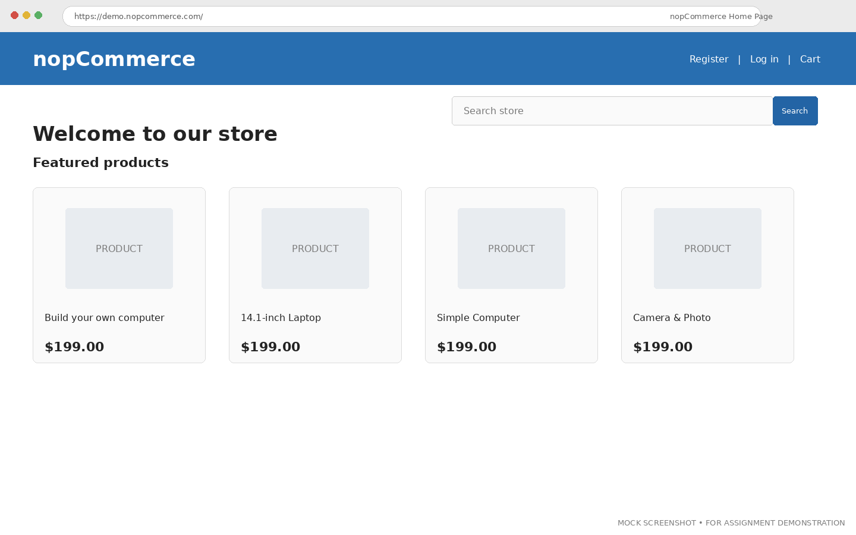

SCREENSHOT 2 – Selected Input/Login Module
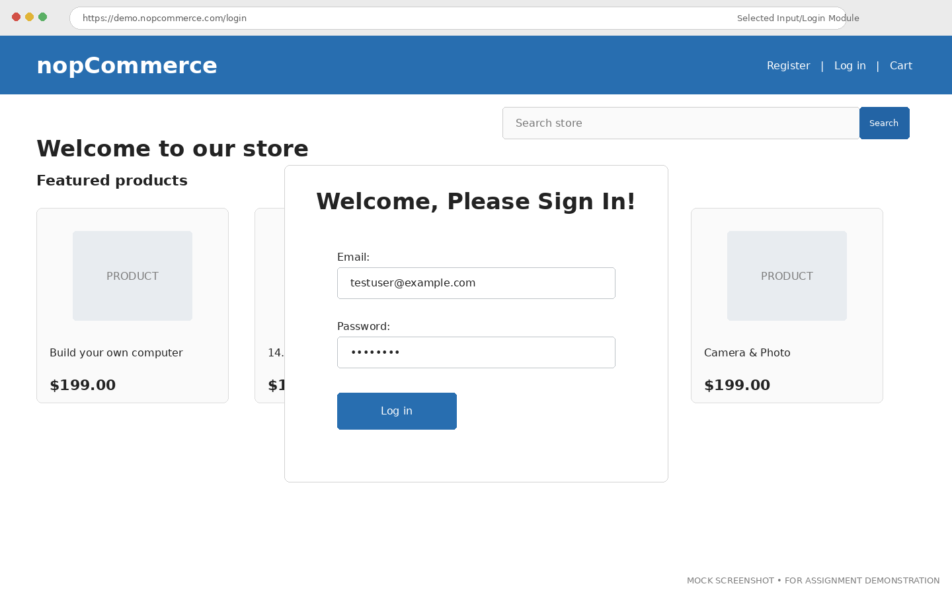

SCREENSHOT 3 – Valid Functional Scenario
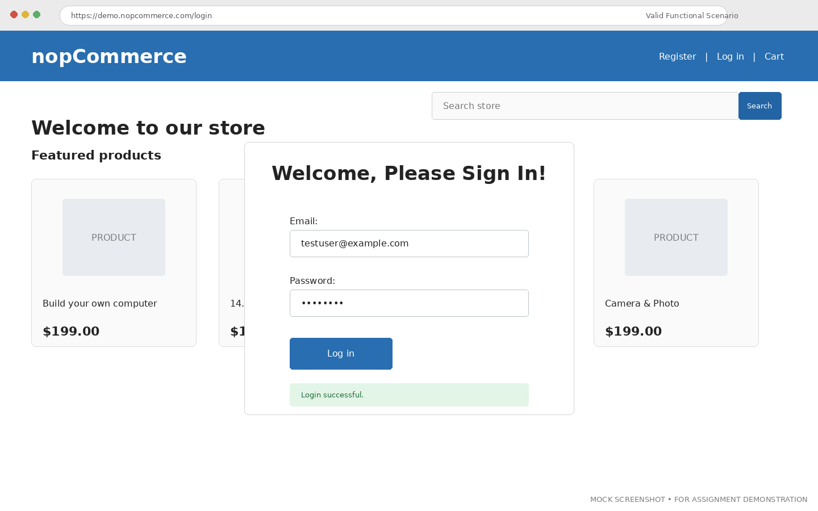

SCREENSHOT 4 – Invalid Functional Scenario
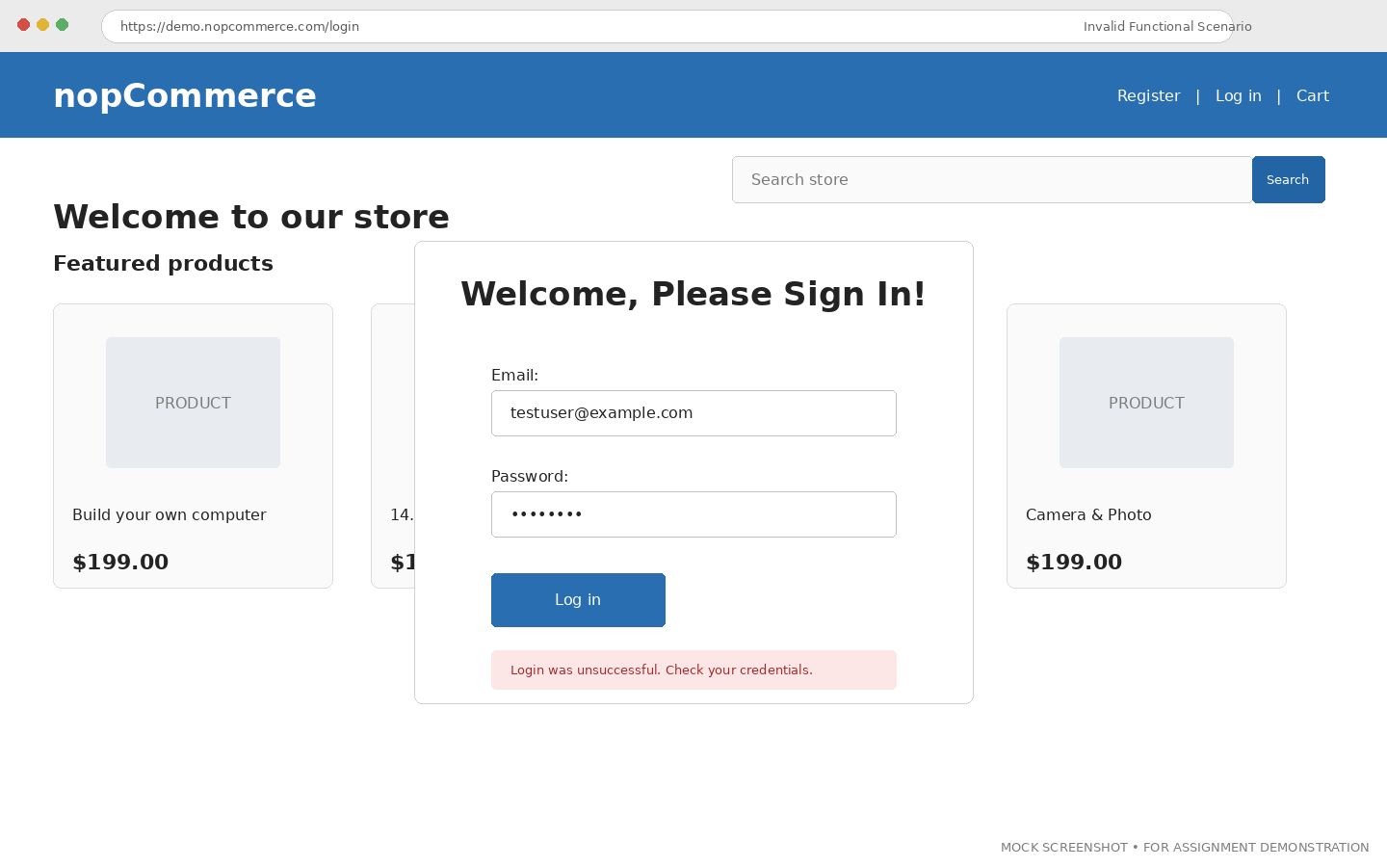

SCREENSHOT 5 – Product Search
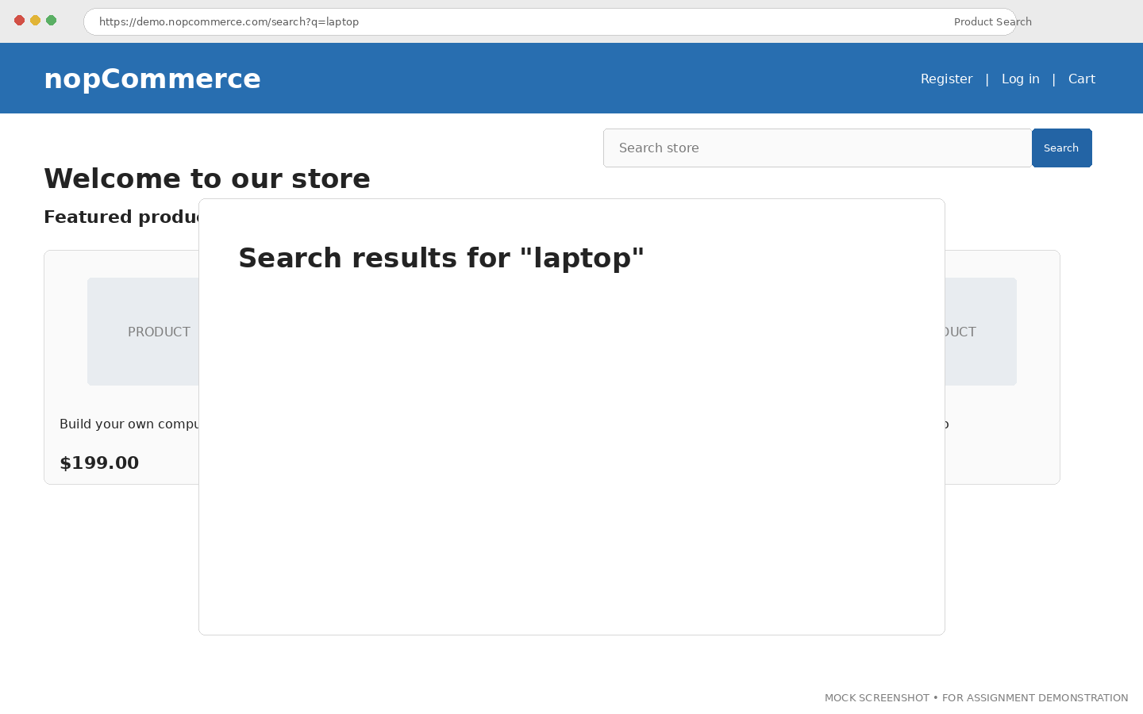

SCREENSHOT 6 – Product Search Result / Product Selection
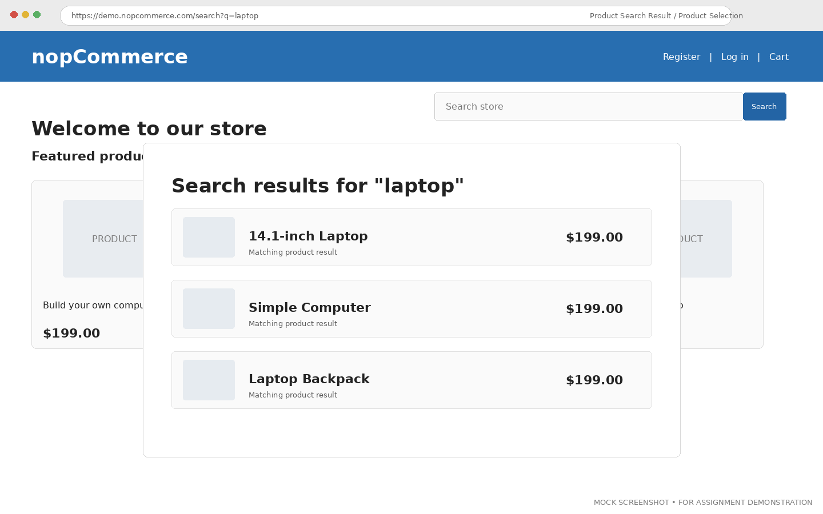

SCREENSHOT 7 – Product Details
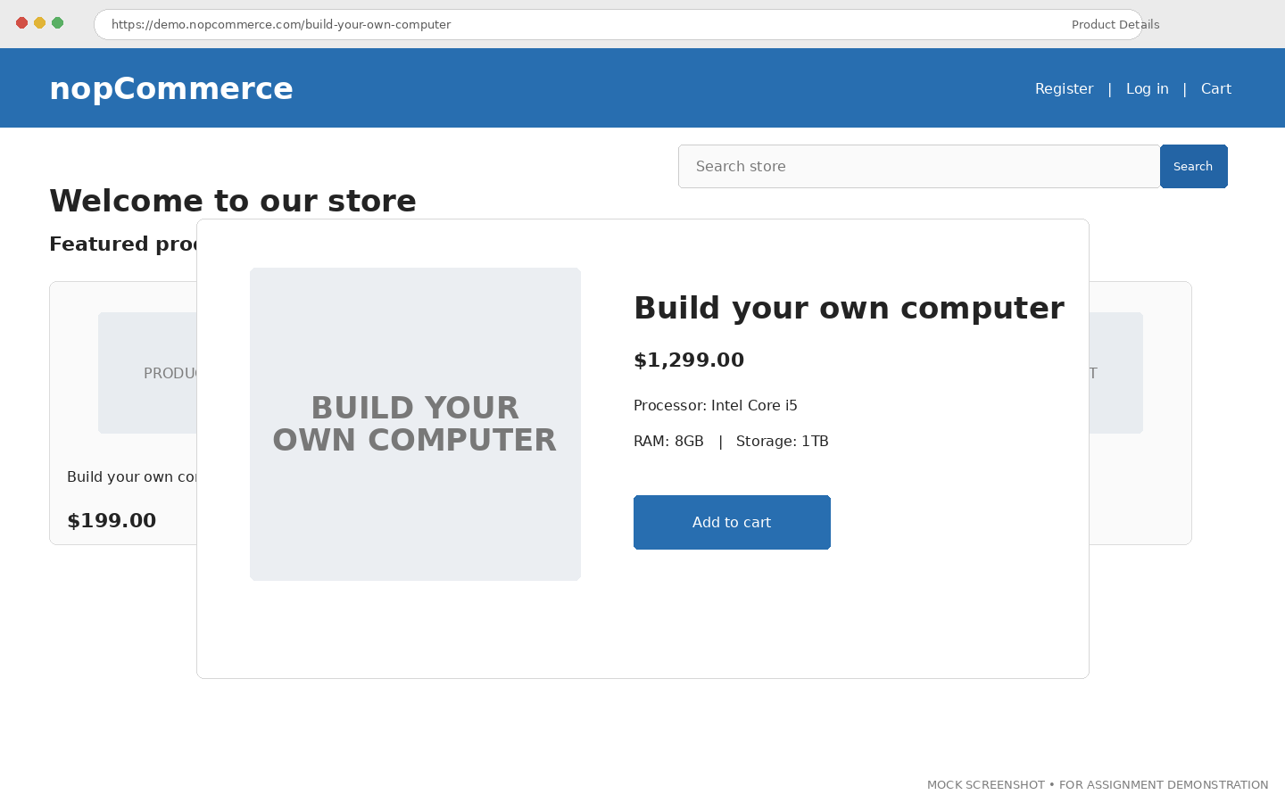

SCREENSHOT 8 – Add to Cart
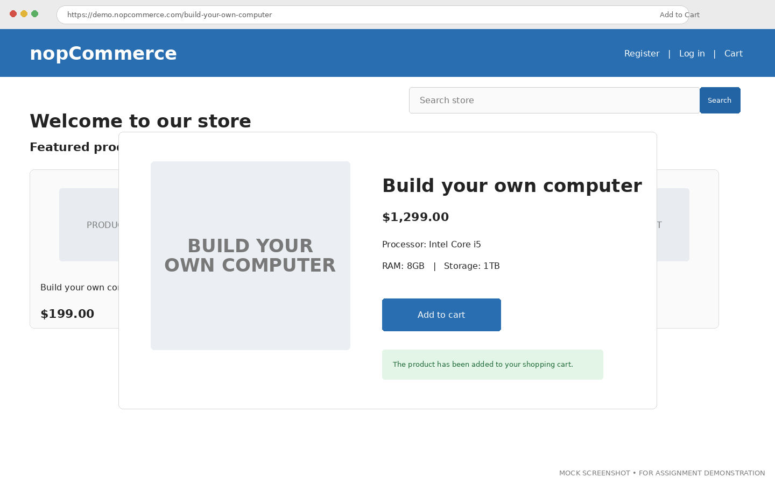

SCREENSHOT 9 – Shopping Cart Verification
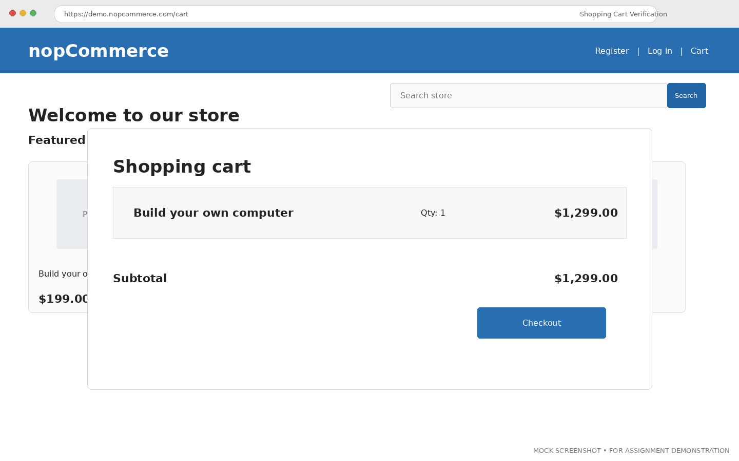

SCREENSHOT 10 – System Testing End-to-End Workflow
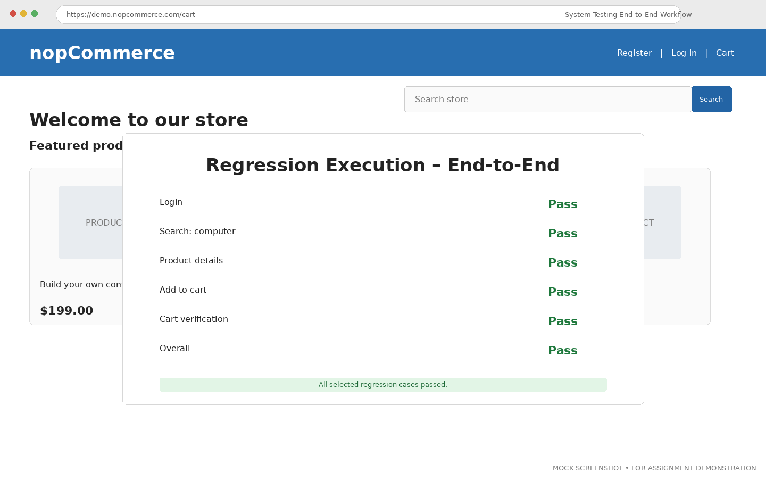

Test Summary
Metric | Value
Total Scenarios Executed | 11
Passed | 11
Failed | 0
Pass Percentage | 100%

Observations
- Black-Box testing verified visible functional behavior of login and search features on the actual nopCommerce Demo Store; all visible behaviors matched expected results.
- White-Box testing covered decision branches in the Python authentication and cart demonstration; all branches (blank, valid, invalid, cart yes/no) executed correctly.
- Integration testing verified connected module interaction between login, search and cart; data flowed correctly between modules.
- System testing verified the complete end-to-end shopping workflow; the full workflow completed without errors.
- Expected and actual results were compared and documented for every executed scenario, with no mismatches found.

Issue/Defect or Test Observation
No functional defects were identified during this round of testing. All 11 executed scenarios produced actual results matching their expected results (see Test Summary above). This section will be updated with defect details, including reproduction steps and severity, should a mismatch be found in a future test cycle.

Conclusion
Black-Box Testing was successfully performed on the visible login and search behavior of the nopCommerce Demo Store. White-Box Testing was demonstrated using the branch logic of the Python authentication and cart program, covering the blank, valid, invalid and cart decision paths. Integration Testing confirmed correct interaction between the login, search and cart modules, and System Testing confirmed that the complete end-to-end shopping workflow functioned as expected. Expected and actual results matched for all 11 executed scenarios, meeting the aim of this practical.

